**Отчет по практике курса «Теория графов» за пятый семестр 2022-2023 учебного года**

**Работу выполнила Сухова Екатерина Владимировна 341 группа МОАИС**

Ссылка на проект на Github: <https://github.com/Ekats3529/Graph_git>

Оглавление

Создание класса Граф 2

Список смежности 18

2. Список смежности Ia + 3. Список смежности Ia 18

4. Список смежности Iб: несколько графов 19

Обходы графа 22

5. Обходы графа II (DFS) 22

6. Обходы графа II (BFS) 25

Построение минимального остовного дерева 28

7. Каркас III (Краскал) 28

Взвешенный граф 30

8. Веса IV а 30

9. Веса IV b 32

10. Веса IV с 35

Потоки 40

11. Максимальный поток V 40

Творческая задача 41

Задание на визуализацию 41

Создание класса Граф

**1. Минимальные требования для класса Граф**

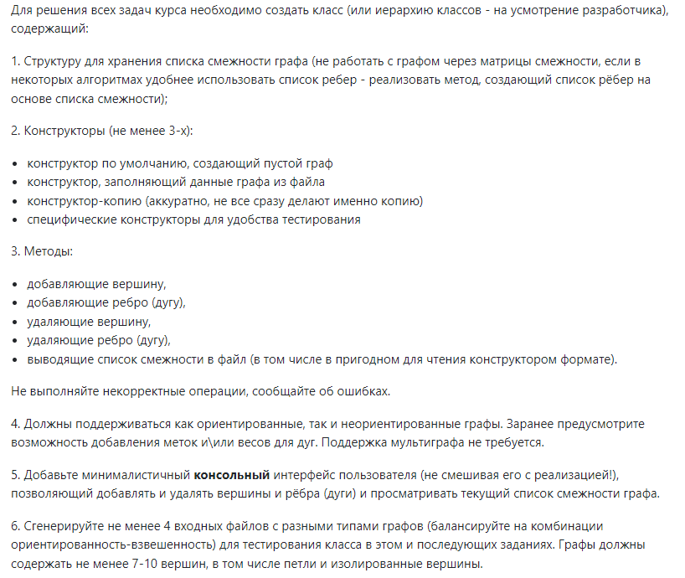

Класс Graph

from copy import deepcopy  
  
  
class Graph:  
 adj_list = {} *# список смежности* type = "!directed" *# тип графа: ориентированный или нет* weighted = False *# тип графа: взвешенный или нет* nodes_list = [] *# список вершин  
  
 # инициализация графа* def __init__(self, *attributes):  
 self.adj_list = {}  
 if len(attributes) > 0:  
 self.type = attributes[0]  
 self.weighted = True if attributes[1] == "weighted" else False  
  
 *# метод для создания списка ребер* def create_edge_list(self, dublicate):  
 edge_list = []  
  
 if not dublicate:  
 edges = []  
 for node in self.adj_list.keys():  
 for adj in self.adj_list[node]:  
 if [node, adj[0]] not in edges:  
 edges.append([adj[0], node])  
 edge_list.append([node, adj[0], adj[1]])  
 else:  
 for node in self.adj_list.keys():  
 for adj in self.adj_list[node]:  
 edge_list.append([node, adj[0], adj[1]])  
  
 return edge_list  
  
 *# метод для создания графа из файла* def create_from_file(self, filename):  
 adj_list = {}  
 try:  
 fin = open(filename, encoding="utf8")  
 except FileNotFoundError:  
 print("ERROR: No such file or directory")  
 return False  
  
 self.type = fin.readline().split()[0]  
 self.weighted = True if fin.readline().split()[0] == "weighted" else False  
 n, m = map(int, fin.readline().split())  
 self.nodes_list = fin.readline().split()  
  
 for node in self.nodes_list:  
 adj_list[node] = []  
  
 edges = fin.readlines()  
 for edge in edges:  
 v, u, c = edge.split()  
 try:  
 if v == u and self.type == "!directed":  
 print(f"ERROR: No loop in not directed graph")  
 return False  
 if u in self.nodes_list:  
 if u not in adj_list[v]:  
 adj_list[v].append([u, c])  
 else:  
 print(f"ERROR: No multiple edges")  
 return False  
 else:  
 print(f"ERROR: No such vertex {u}")  
 return False  
 except KeyError:  
 print(f"ERROR: No such vertex {v}")  
 return False  
  
 if self.type == "!directed":  
 try:  
 if v in self.nodes_list:  
 if u not in adj_list[v]:  
 adj_list[u].append([v, c])  
 else:  
 print(f"ERROR: No multiple edges")  
 return False  
 else:  
 print(f"ERROR: No such vertex {v}")  
 return False  
 except KeyError:  
 print(f"ERROR: No such vertex {u}")  
 return False  
  
 self.adj_list = adj_list  
 return True  
  
 *# метод для создания копии графа* def copy(self):  
 cp_graph = Graph(self.type, "weighted" if self.weighted else "!weighted")  
 cp_graph.adj_list = deepcopy(self.adj_list)  
 cp_graph.nodes_list = self.nodes_list.copy()  
 return cp_graph  
  
 *# метод для добавления вершины* def add_node(self, node):  
 if node in self.nodes_list:  
 print(f"ERROR: Unable to add vertex {node}. The same vertex already exist")  
 return False  
 self.adj_list[node] = []  
 self.nodes_list.append(node)  
 return True  
  
 *# метод для добавления ребра (дуги)* def add_edge(self, edge):  
 if len(edge) < 2:  
 print(f"Unable to add the edge")  
 return False  
 v, u = edge[0], edge[1]  
 c = '1'  
 fl = False  
 if self.weighted:  
 try:  
 c = edge[2]  
 except (KeyError, IndexError):  
 print(f"Unable to add the edge. No weight entered")  
 return False  
 else:  
 if len(edge) == 3:  
 print("This graph is not weighted, so the weight of this edge not counted")  
 try:  
 if self.weighted:  
 if v == u and self.type == "!directed":  
 print(f"Unable to add the edge. No loop in not directed graph")  
 return False  
 nodes = [x[0] for x in self.adj_list[v]]  
 if u in nodes:  
 print(f"Do you want to change the weight of edge {v} {u} "  
 f"from {self.adj_list[v][nodes.index(u)][1]} to {c} "  
 f"Y/N")  
 ans = input()  
 if ans == "Y":  
 fl = True  
 self.adj_list[v][nodes.index(u)][1] = c  
 else:  
 if u in self.nodes_list and v in self.nodes_list:  
 self.adj_list[v].append([u, c])  
 else:  
 print(f"Unable to add the edge. No such vertex")  
 return False  
 else:  
 if v == u and self.type == "!directed":  
 print(f"Unable to add the edge. No loop in not directed graph")  
 return False  
 if [u, c] not in self.adj_list[v]:  
 if u in self.nodes_list and v in self.nodes_list:  
 self.adj_list[v].append([u, c])  
 else:  
 print(f"Unable to add the edge. No such vertex")  
 return False  
 else:  
 print(f"Unable to add the edge. Same edge already exists")  
 return False  
  
 except KeyError:  
 print(f"Unable to add the edge. No such vertex {v}")  
 return False  
  
 if self.type != "directed":  
 try:  
 if self.weighted:  
  
 nodes = [x[0] for x in self.adj_list[u]]  
 if v in nodes:  
 if fl:  
 self.adj_list[u][nodes.index(v)][1] = c  
 else:  
 if u in self.nodes_list and v in self.nodes_list:  
 self.adj_list[u].append([v, c])  
 else:  
 print(f"Unable to add the edge. No such vertex")  
 return False  
 else:  
 if [v, c] not in self.adj_list[u]:  
 if u in self.nodes_list and v in self.nodes_list:  
 self.adj_list[u].append([v, c])  
 else:  
 print(f"Unable to add the edge. No such vertex")  
 return False  
 else:  
 print(f"Unable to add the edge. Same edge already exists")  
 return False  
 except KeyError:  
 print(f"Unable to add the edge. No such vertex {u}")  
 return False  
 return True  
  
 *# метод для удаления вершины* def delete_node(self, node):  
 try:  
 for item in self.adj_list.items():  
 nodes = [x[0] for x in item[1]]  
 if node in nodes:  
 del self.adj_list[item[0]][nodes.index(node)]  
 del self.adj_list[node]  
 del self.nodes_list[self.nodes_list.index(node)]  
 except KeyError:  
 print(f"ERROR: No such vertex {node}")  
 return False  
 return True  
  
 *# метод для удаления ребра (дуги)* def delete_edge(self, edge):  
 v, u = edge[0], edge[1]  
  
 try:  
 nodes = [x[0] for x in self.adj_list[v]]  
 del self.adj_list[v][nodes.index(u)]  
 except (KeyError, ValueError):  
 print(f"ERROR: No such edge ({v}, {u})")  
 return False  
  
 if self.type != "directed":  
 try:  
 nodes = [x[0] for x in self.adj_list[u]]  
 del self.adj_list[u][nodes.index(v)]  
 except (KeyError, ValueError):  
 print(f"ERROR: No such edge ({u}, {v})")  
 return False  
 return True  
  
 *# метод для вывода графа в файл* def print_to_file(self, filename):  
 try:  
 fout = open(filename, 'w', encoding="utf8")  
 except FileNotFoundError:  
 print("ERROR: No such file or directory")  
 return False  
 lst = self.create_edge_list(False)  
 print(self.type, file=fout)  
 print("weighted" if self.weighted else "!weighted", file=fout)  
 print(len(self.nodes_list), len(lst), file=fout)  
 print(" ".join(self.nodes_list), file=fout)  
 for edge in lst:  
 print(f"{edge[0]} {edge[1]}", file=fout)  
 return True  
  
 *# метод для вывода списка смежности в консоль* def print_to_console(self):  
 print()  
 if self.weighted:  
 for item in self.adj_list.items():  
 nodes = ["(" + ",".join([x[0], x[1]]) + ")" for x in item[1]]  
 line = " ".join(nodes)  
 print(f"{item[0]}: {line}")  
 else:  
 for item in self.adj_list.items():  
 nodes = [x[0] for x in item[1]]  
 line = " ".join(nodes)  
 print(f"{item[0]}: {line}")

Файл *main.py* в котором реализован консольные интерфейс

import tasks  
from graph import Graph  
  
commands_num = {"1": "CREATE EMPTY", "2": "CREATE FILE", "3": "COPY", "4": "CHOOSE GRAPH",  
 "5": "ADD VERTEX", "6": "ADD EDGE", "7": "DELETE VERTEX", "8": "DELETE EDGE",  
 "9": "PRINT LIST EDGES FILE", "10": "PRINT LIST EDGES CONSOLE", "11": "PRINT ADJACENCY LIST CONSOLE",  
 "13": "HELP", "14": "PRINT LIST COMMANDS", "15": "PRINT LIST GRAPHS", "0": "EXIT"}  
  
commands = {"CREATE EMPTY": "Create a new empty graph",  
 "CREATE FILE": "Create a new graph from the file",  
 "COPY": "Create the copy of existing graph",  
 "CHOOSE GRAPH": "Choose the name if graph to work with",  
 "ADD VERTEX": "Add a vertex to the graph",  
 "ADD EDGE": "Add an edge to the graph",  
 "DELETE VERTEX": "Remove a vertex from the graph",  
 "DELETE EDGE": "Remove an edge from the graph",  
 "PRINT LIST EDGES FILE": "Print list of edges to the file",  
 "PRINT LIST EDGES CONSOLE": "Print list of edges to the console(there)",  
 "PRINT ADJACENCY LIST CONSOLE": "Print adjacency list to the console(there)",  
 "HELP": "Print the hint for the command",  
 "EXIT": "Exit the execution",  
 "PRINT LIST COMMANDS": "Print list of commands to the console(there)",  
 "PRINT LIST GRAPHS": "Print list of graphs to the console(there)"  
 }  
  
graphs = {}  
chosen_graph = None  
  
  
def print_menu():  
 print("Enter the command from the list")  
 for items in commands_num.items():  
 print(items[0], items[1])  
  
  
def create(*filename):  
 fl = True  
 if len(filename) == 1:  
 gr = Graph()  
 fl = gr.create_from_file(filename[0])  
 else:  
 print("Enter the type of graph: directed or !directed")  
 type = input()  
 if type != "directed" and type != "!directed":  
 print("ERROR: Unexpected type")  
 return  
 print("Enter the type of graph: weighted or !weighted")  
 weight = input()  
 if weight != "weighted" and weight != "!weighted":  
 print("ERROR: Unexpected type")  
 return  
 gr = Graph(type, weight)  
  
 if fl:  
 print("Enter the name for the new graph")  
 name = input()  
 while name in graphs.keys():  
 print("This name already exists. Enter another")  
 name = input()  
 else:  
 graphs[name] = gr  
  
  
def get_graph_by_name(name):  
 global chosen_graph  
 if name is None:  
 print("Enter the name of graph or enter STOP to stop entering")  
 in_name = input()  
 if in_name in graphs.keys():  
 chosen_graph = in_name  
 return graphs[chosen_graph]  
 else:  
 while in_name not in graphs.keys():  
 print("ERROR. Try to enter another name or STOP to stop entering")  
 in_name = input()  
 if in_name == "STOP":  
 chosen_graph = None  
 return None  
 else:  
 chosen_graph = in_name  
  
 return graphs[chosen_graph]  
 chosen_graph = name  
 return graphs[name]  
  
  
if __name__ == '__main__':  
 print_menu()  
 print("\nENTER THE COMMAND: ", end="")  
 command = input()  
 cur_graph = None  
 while command != "EXIT" and command != "0":  
 if command not in commands.keys() and command not in commands_num.keys():  
 print("ERROR: UNKNOWN COMMAND")  
  
 else:  
 if command == "EXIT" or command == "0":  
 exit(0)  
  
 elif command == "HELP" or command == "13":  
 fl = False  
 print("To exit HELP enter STOP")  
 print("Enter the name of command")  
 name = input()  
 while name != "STOP":  
 while name not in commands.keys():  
 if name == "STOP":  
 fl = True  
 break  
 print("Wrong value. Enter name of command again")  
 name = input()  
 else:  
 print(f"{name} : {commands[name]}")  
 print("To exit HELP enter STOP")  
 if fl:  
 break  
 print("Enter the name of command")  
 name = input()  
  
 elif command == "CREATE EMPTY" or command == "1":  
 create()  
  
 elif command == "CHOOSE GRAPH" or command == "4":  
 cur_graph = get_graph_by_name(None)  
  
 elif command == "CREATE FILE" or command == "2":  
 print("Enter the name of file")  
 create(input())  
  
 elif command == "COPY" or command == "3":  
 if cur_graph is None:  
 cur_graph = get_graph_by_name(None)  
 if cur_graph is not None:  
 print(f"Current graph is: {chosen_graph}")  
 print("Enter the name of the copy-graph: ", end="")  
 name = input()  
 if name not in graphs.keys():  
 graphs[name] = cur_graph.copy()  
 else:  
 while name in graphs.keys():  
 print("ERROR. Try to enter another name or STOP to stop entering")  
 name = input()  
 if name == "STOP":  
 break  
 else:  
 graphs[name] = cur_graph.copy()  
  
 elif command == "ADD VERTEX" or command == "5":  
 if cur_graph is None:  
 cur_graph = get_graph_by_name(None)  
 if cur_graph is not None:  
 print(f"Current graph is: {chosen_graph}")  
 print("Enter the vertex to add: ", end="")  
 node = input()  
 cur_graph.add_node(node)  
  
 elif command == "ADD EDGE" or command == "6":  
 if cur_graph is None:  
 cur_graph = get_graph_by_name(None)  
 if cur_graph is not None:  
 print(f"Current graph is: {chosen_graph}")  
 print("Enter the edge to add: ", end="")  
 edge = input().split()  
 cur_graph.add_edge(edge)  
  
 elif command == "DELETE VERTEX" or command == "7":  
 if cur_graph is None:  
 cur_graph = get_graph_by_name(None)  
 if cur_graph is not None:  
 print(f"Current graph is: {chosen_graph}")  
 print("Enter the vertex to delete: ", end="")  
 node = input()  
 cur_graph.delete_node(node)  
  
 elif command == "DELETE EDGE" or command == "8":  
 if cur_graph is None:  
 cur_graph = get_graph_by_name(None)  
 if cur_graph is not None:  
 print(f"Current graph is: {chosen_graph}")  
 print('Enter the edge to delete":', end="")  
 edge = input().split()  
 cur_graph.delete_edge(edge)  
  
 elif command == "PRINT LIST EDGES FILE" or command == "9":  
 if cur_graph is None:  
 cur_graph = get_graph_by_name(None)  
 if cur_graph is not None:  
 print(f"Current graph is: {chosen_graph}")  
 print("Enter the name of file")  
 filename = input()  
 cur_graph.print_to_file(filename)  
  
 elif command == "PRINT LIST EDGES CONSOLE" or command == "10":  
 if cur_graph is None:  
 cur_graph = get_graph_by_name(None)  
 if cur_graph is not None:  
 print(f"Current graph is: {chosen_graph}")  
 lst = cur_graph.create_edge_list(False)  
 for e in lst:  
 if cur_graph.weighted:  
 print(*e)  
 else:  
 print(f"{e[0]} {e[1]}")

elif command == "PRINT ADJACENCY LIST CONSOLE" or command == "11":  
 if cur_graph is None:  
 cur_graph = get_graph_by_name(None)  
 if cur_graph is not None:  
 print(f"Current graph is: {chosen_graph}")  
 cur_graph.print_to_console()  
  
 elif command == "PRINT LIST COMMANDS" or command == "14":  
 print_menu()  
  
 elif command == "PRINT LIST GRAPHS" or command == "15":  
 for gr in graphs.items():  
 print(f"Name: {gr[0]}\tAdjacency list: ", end="")  
 gr[1].print_to_console()  
 print()  
  
 print("\nENTER THE COMMAND: ", end="")  
 command = input()

Далее все задачи реализованы в виде отдельных методов в поключенном файле *tasks.py*

Примеры

**Создание графа из файла**

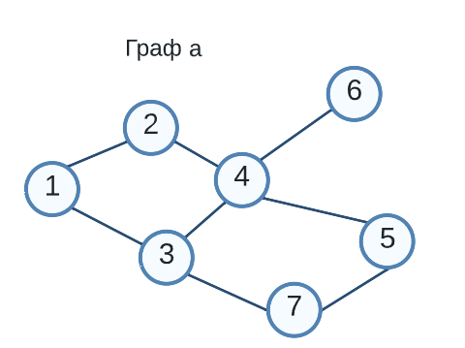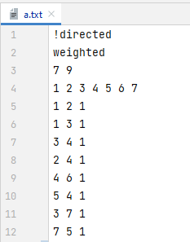 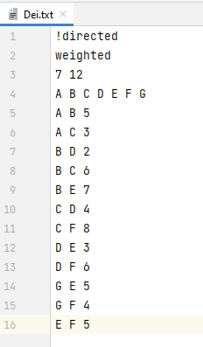

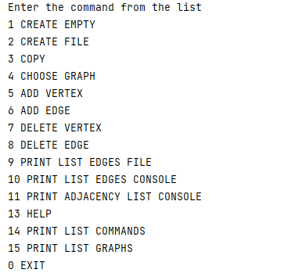

Ошибка при неправильном имени файла и при неизвестной команде

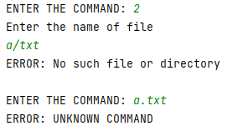

Создание и выбор графа

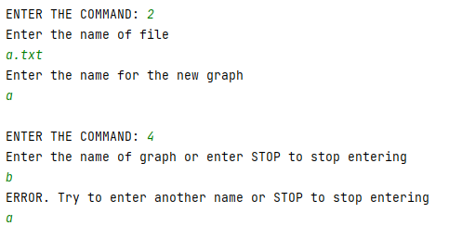

Вывод списка смежности (при невзвешенном графе)

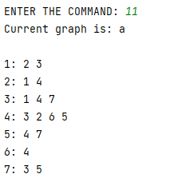

Вывод списка смежности (при взвешенном графе)

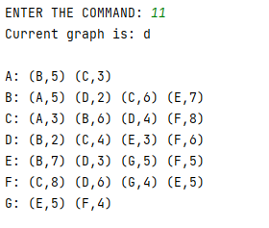

Вывод всех графов

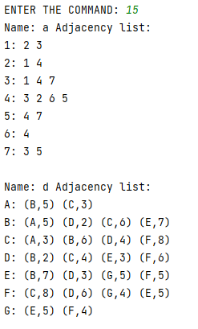

Завершение работы с программой

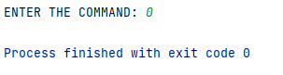

**Создание пустого графа и его наполнение**

Создание графа

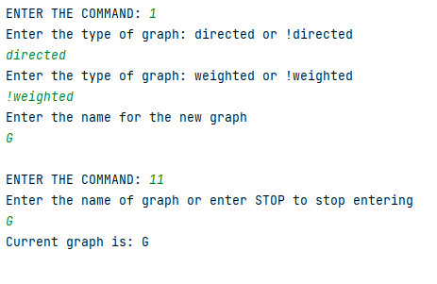

Добавление вершин

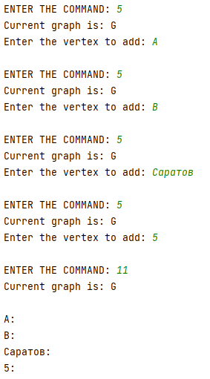

Попытка добавить существующую вершину

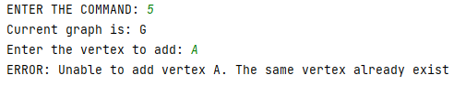

Добавление ребер

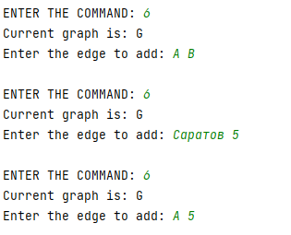

Попытка ввести в невзвешенных граф ребро с весом

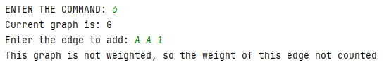

Попытка добавить существующее ребро

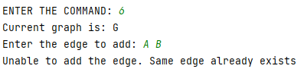

Результат

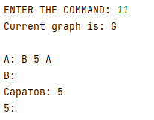

**Удаление вершин и ребер**

Удаление вершин

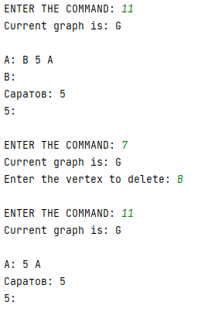

Попытка удалить несуществующую вершину

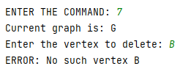

Удаление ребра (дуги)

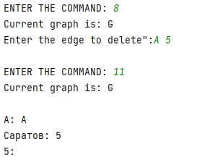

Попытка удалить несуществующее ребро

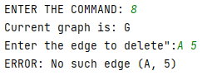

**Вывод в файл и консоль**

Вывод списка смежности в консоль

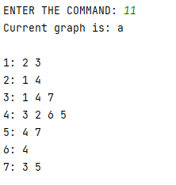

Вывод списка ребер в консоль

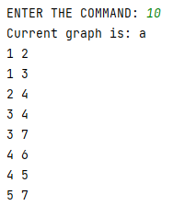

Вывод списка ребер в файл (реализовано так, чтобы потом этот же файл можно было бы считать)

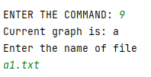

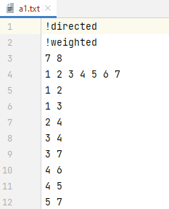

**Копия графа (+ проверка)**

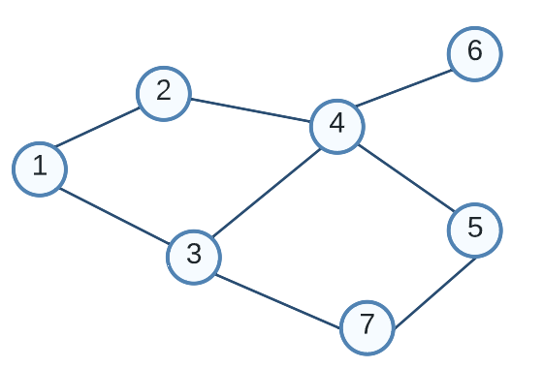 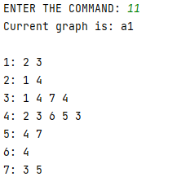

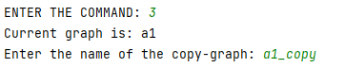 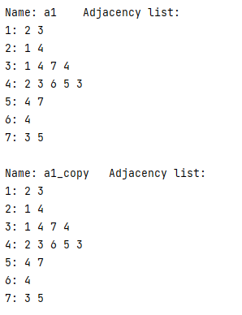

Проверим, удалив ребро из копии

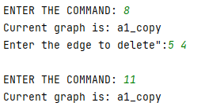

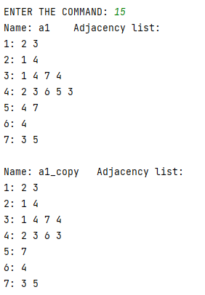

Теперь удалим вершину из графа основы

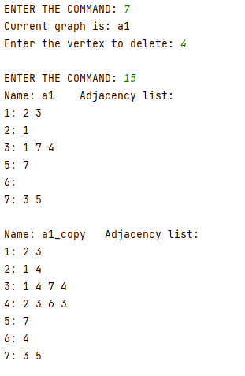

Список смежности

2. Список смежности Ia + 3. Список смежности Ia





Файл *main.py*

elif command == "IN DEGREE" or command == "100":  
 if cur_graph is None:  
 cur_graph = get_graph_by_name(None)  
 if cur_graph is not None:  
 print(f"Current graph is: {chosen_graph}")  
 print("Enter the node")  
 node = input()  
 ans = tasks.in_deg(cur_graph, node)  
 if ans != -1:  
 if cur_graph.type == "!directed":  
 print("This graph is not directed")  
 print(f"degree {ans[0]}\nneighbours {' '.join(ans[1])}")  
 else:  
 print(f"income degree {ans[0]}\nincome neighbours {' '.join(ans[1])}")

Файл *tasks.py*

def in_deg(graph, node):  
 if node not in graph.nodes_list:  
 print(f"No such vertex {node}")  
 return -1  
 ans = 0  
 neib = []  
 for item in graph.adj_list.items():  
 nodes = [x[0] for x in item[1]]  
 if node in nodes:  
 neib.append(item[0])  
 ans += 1  
 return ans, neib

Примеры

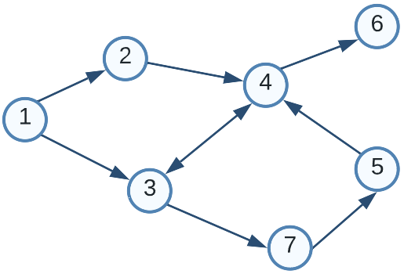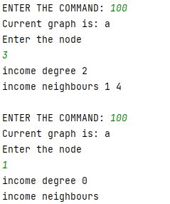

4. Список смежности Iб: несколько графов



Файл *main.py*

elif command == "TASK Ib 18" or command == "101":  
 if cur_graph is None:  
 cur_graph = get_graph_by_name(None)  
 if cur_graph is not None:  
 print(f"Current graph is: {chosen_graph}")  
 if cur_graph.type == "directed":  
 print(f"Unable to create the new graph from {chosen_graph}")  
 else:  
 new_gr = tasks.new_graph(cur_graph)  
 new_gr.print_to_console()  
 print("Would you like to add new graph to list of graphs? Y/N")  
 ans = input()  
 if ans == "Y":  
 print("Enter the name of the new-graph: ", end="")  
 name = input()  
 if name not in graphs.keys():  
 graphs[name] = new_gr  
 else:  
 while name in graphs.keys():  
 print("ERROR. Try to enter another name or STOP to stop entering")  
 name = input()  
 if name == "STOP":  
 break  
 else:  
 graphs[name] = new_gr  
 elif ans != "N":  
 print("Cannot recognise the answer")

Файл *tasks.py*

def new_graph(graph):  
 gr = graph.copy()  
 del_nodes = []  
 for node in gr.adj_list.items():  
 if len(node[1]) % 2 != 0:  
 del_nodes.append(node[0])  
 for node in del_nodes:  
 gr.delete_node(node)  
 return gr

Примеры

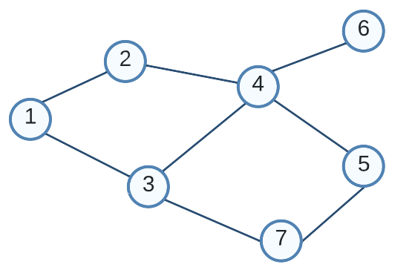 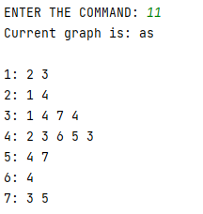

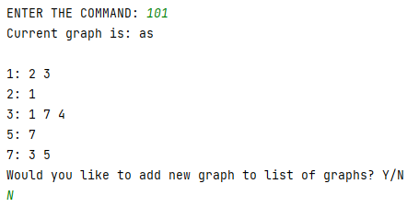

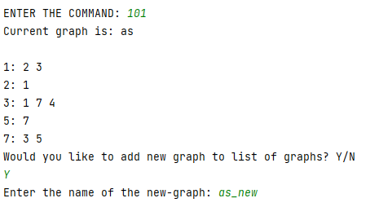

Применим метод еще раз к полученному графу

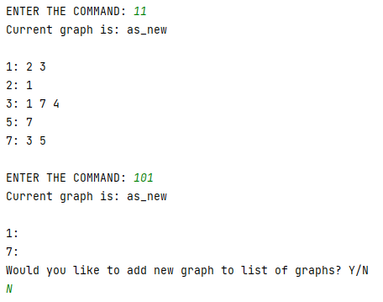

**Пример для полного графа K6 (будут удалены все вершины)**

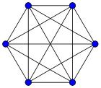 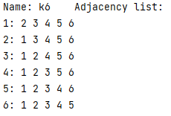

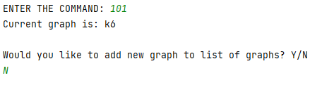

**Пример для полного графа K5 (не будет удалено ни одной вершины)**

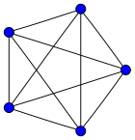 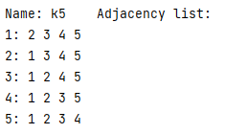

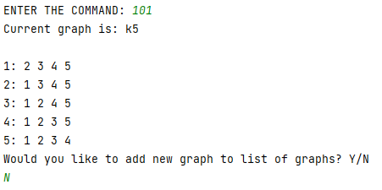

Обходы графа

5. Обходы графа II (DFS)



Файл *main.py*

elif command == "ACYCLE" or command == "102":  
 if cur_graph is None:  
 cur_graph = get_graph_by_name(None)  
 if cur_graph is not None:  
 print(f"Current graph is: {chosen_graph}")  
 res = tasks.acycle(cur_graph)  
 if res:  
 print("Acycle")  
 elif not res:  
 print("Got a cycle")

Файл *tasks.py*

color = []  
cycle = False  
INF = 1e15  
  
  
def dfs(node, gr):  
 global color, cycle  
 color[gr.nodes_list.index(node)] = 1  
 lst = [x[0] for x in gr.adj_list[node]]  
 for nd in lst:  
 if color[gr.nodes_list.index(nd)] == 0:  
 dfs(nd, gr)  
 elif color[gr.nodes_list.index(nd)] == 1:  
 cycle = True  
  
 color[gr.nodes_list.index(node)] = 2  
  
  
def acycle(graph):  
 if graph.type == "!directed":  
 print("Graph is not directed")  
 return  
 global color, cycle  
 gr = graph.copy()  
 color = [0 for _ in range(len(gr.nodes_list))]  
 for node in gr.nodes_list:  
 if color[gr.nodes_list.index(node)] == 0:  
 dfs(node, gr)  
 if cycle:  
 return False  
 return True

Примеры

**Связный орграф с циклом**

 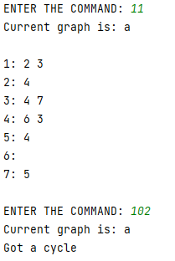

**Связный орграф без цикла**

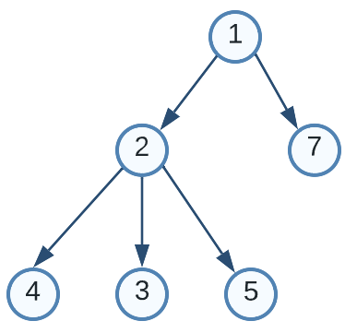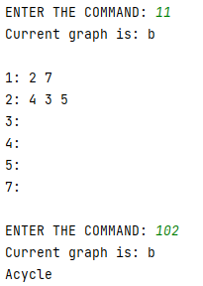

**Несвязный орграф с циклом**

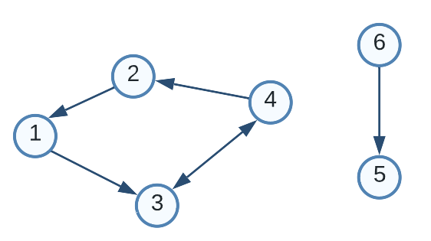 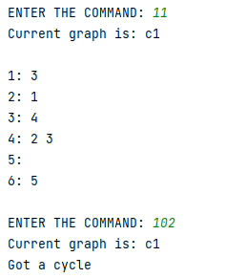

**Несвязный орграф без цикла**

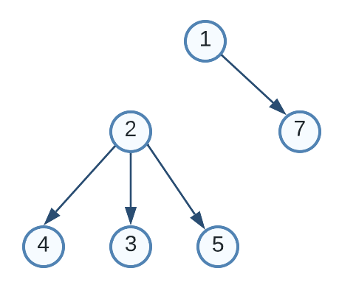 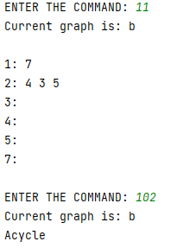

6. Обходы графа II (BFS)



Файл *main.py*

elif command == "K_PATH" or command == "103":  
 if cur_graph is None:  
 cur_graph = get_graph_by_name(None)  
 if cur_graph is not None:  
 print(f"Current graph is: {chosen_graph}")  
 print("Enter the value of k: ", end="")  
 try:  
 k = int(input())  
 tasks.k_path(cur_graph, k)  
 except ValueError:  
 print("ERROR Value of k is not integer")

Файл *tasks.py*

def bfs(s, gr):  
 used = [False for _ in range(len(gr.nodes_list))]  
 d = [-1 for _ in range(len(gr.nodes_list))]  
 p = [None for _ in range(len(gr.nodes_list))]  
 used[gr.nodes_list.index(s)] = True  
 q = Queue()  
 q.put(s)  
 while not q.empty():  
 node = q.get()  
 lst = [x[0] for x in gr.adj_list[node]]  
 for nd in lst:  
 to = gr.nodes_list.index(nd)  
 if not used[to]:  
 used[to] = True  
 q.put(nd)  
 d[to] = d[gr.nodes_list.index(node)] + 1  
 p[to] = node  
 return d, p  
  
  
def k_path(graph, k):  
 gr = graph.copy()  
 ans = []  
 for node in gr.nodes_list:  
 d, p = bfs(node, gr)  
 if max(d) + 1 <= k and d.count(-1) == 1:  
 ans.append(node)  
 *#print(node, d, p)* print(f"The list of vertexes which shortest way to others <= {k}: {' '.join(ans)}")

Примеры

**Связный орграф**

 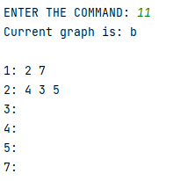

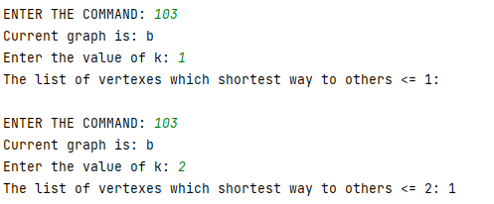

**Сильно-связный орграф**

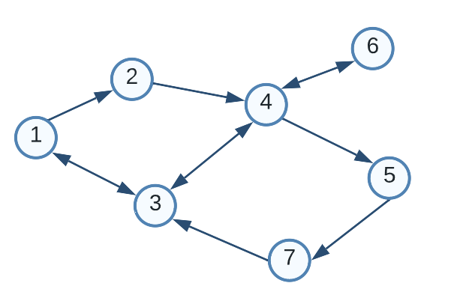 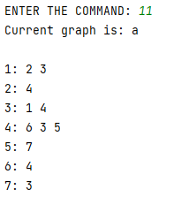

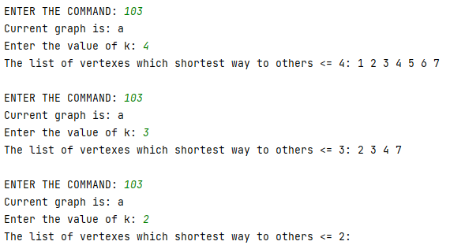

**Связный граф**

 

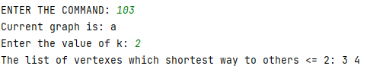

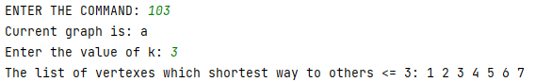

**Несвязный граф**

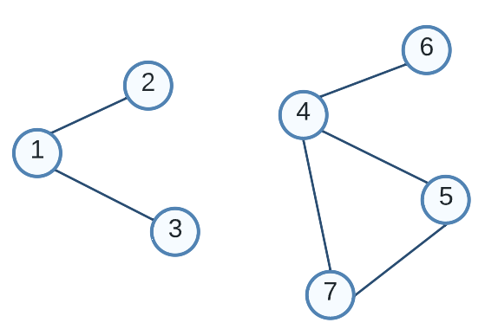 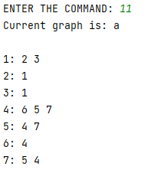

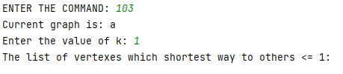

Построение минимального остовного дерева

7. Каркас III (Краскал)

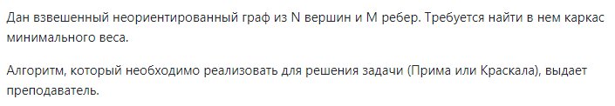

Файл *main.py*

elif command == "KRUSKAL" or command == "104":  
 if cur_graph is None:  
 cur_graph = get_graph_by_name(None)  
 if cur_graph is not None:  
 print(f"Current graph is: {chosen_graph}")  
 tasks.kruskal(cur_graph)

Файл *tasks.py*

def search(gr, parent, i):  
 if parent[gr.nodes_list.index(i)] == i:  
 return i  
 return search(gr, parent, parent[gr.nodes_list.index(i)])  
  
  
def apply_union(gr, parent, rank, x, y):  
 xroot = search(gr, parent, x)  
 yroot = search(gr, parent, y)  
 if rank[gr.nodes_list.index(xroot)] < rank[gr.nodes_list.index(yroot)]:  
 parent[gr.nodes_list.index(xroot)] = yroot  
 elif rank[gr.nodes_list.index(xroot)] > rank[gr.nodes_list.index(yroot)]:  
 parent[gr.nodes_list.index(yroot)] = xroot  
 else:  
 parent[gr.nodes_list.index(yroot)] = xroot  
 rank[gr.nodes_list.index(xroot)] += 1  
  
  
def kruskal(graph):  
 if graph.type == "directed":  
 print("ERROR: Incorrect type of graph")  
 return  
 gr = graph.copy()  
 n = len(gr.nodes_list)  
 result = []  
 i, j = 0, 0  
 edge_list = gr.create_edge_list(False)  
 parent = [gr.nodes_list[i] for i in range(n)]  
 rank = [0 for _ in range(n)]  
 try:  
 edge_list = sorted(edge_list, key=lambda item: int(item[2]))  
 while j < n - 1:  
 if i > len(edge_list) - 1:  
 print("EROOR: Can't build the tree")  
 return  
 u, v, w = edge_list[i]  
 i += 1  
 x = search(graph, parent, u)  
 y = search(graph, parent, v)  
 if x != y:  
 j += 1  
 result.append([u, v, w])  
 apply_union(graph, parent, rank, x, y)  
 except ValueError:  
 print("ERROR: Incorrect type of weight")  
 return  
 result_weight = 0  
 for u, v, weight in result:  
 result_weight += int(weight)  
 print(f"({u}, {v}) - {weight}")  
 print(f"Weight of all graph: {result_weight}")

Примеры

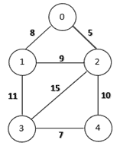 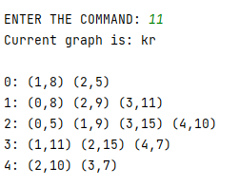

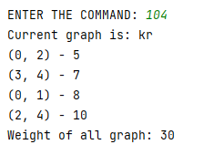

Добавим изолированную вершину

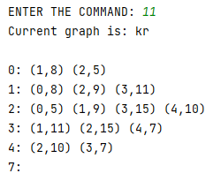

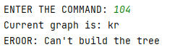

Взвешенный граф



8. Веса IV а





Файл *main.py*

elif command == "DIJKSTRA" or command == "201":  
 if cur_graph is None:  
 cur_graph = get_graph_by_name(None)  
 if cur_graph is not None:  
 print(f"Current graph is: {chosen_graph}")  
 print(f"Enter the node u: ", end="")  
 u = input()  
 print(f"Enter the node v1: ", end="")  
 v1 = input()  
 print(f"Enter the node v2: ", end="")  
 v2 = input()  
 if u not in cur_graph.nodes_list or v1 not in cur_graph.nodes_list or v2 not in cur_graph.nodes_list:  
 print("ERROR No such node")  
 else:  
 d, pr = tasks.dijkstra(cur_graph, u)  
 *#print(d, pr)* if d[cur_graph.nodes_list.index(v1)] != tasks.INF:  
 print(f"min distance between {u} & {v1}: {d[cur_graph.nodes_list.index(v1)]}")  
 path = []  
 v = cur_graph.nodes_list.index(v1)  
 s = cur_graph.nodes_list.index(u)  
 while v != s:  
 path.append(cur_graph.nodes_list[v])  
 v = pr[v]  
 print(f"Path: {u}-{'-'.join(path[::-1])}")  
 else:  
 print(f"No path between {u} & {v1}")  
  
 if d[cur_graph.nodes_list.index(v2)] != tasks.INF:  
 print(f"min distance between {u} & {v2}: {d[cur_graph.nodes_list.index(v2)]}")  
 path = []  
 v = cur_graph.nodes_list.index(v2)  
 s = cur_graph.nodes_list.index(u)  
 while v != s:  
 path.append(cur_graph.nodes_list[v])  
 v = pr[v]  
 print(f"Path: {u}-{'-'.join(path[::-1])}")  
 else:  
 print(f"No path between {u} & {v2}")

Файл *tasks.py*

def dijkstra(graph, s):  
 gr = graph.copy()  
 n = len(gr.nodes_list)  
 d = [INF] * n  
 pr = [0] * n  
 d[gr.nodes_list.index(s)] = 0  
 used = [False for _ in range(len(gr.nodes_list))]  
 for i in range(n):  
 v = -1  
 for j in range(n):  
 if not used[j] and (v == -1 or d[j] < d[v]):  
 v = j  
 if d[v] == INF:  
 break  
 used[v] = True  
 lst = gr.adj_list[gr.nodes_list[v]]  
 for nd in lst:  
 to = gr.nodes_list.index(nd[0])  
 ln = int(nd[1])  
 if d[v] + ln < d[to]:  
 d[to] = d[v] + ln  
 pr[to] = v  
 return d, pr

Примеры

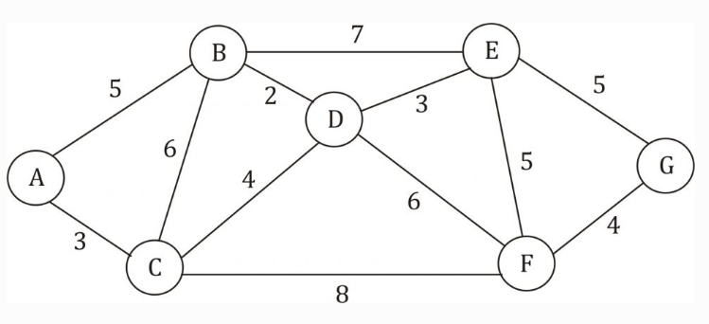

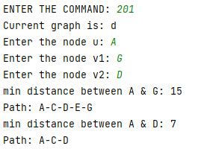

При добавлении изолированной вершины H

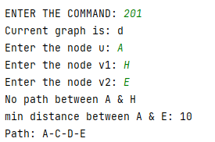

9. Веса IV b





Файл *main.py*

elif command == "BELLMAN_FORD" or command == "202":  
 if cur_graph is None:  
 cur_graph = get_graph_by_name(None)  
 if cur_graph is not None:  
 print(f"Current graph is: {chosen_graph}")  
 print(f"Enter the node u: ", end="")  
 u = input()  
 if u not in cur_graph.nodes_list:  
 print("ERROR No such node")  
 else:  
 n = len(cur_graph.nodes_list)  
 for v in range(n):  
 if cur_graph.nodes_list[v] != u:  
 d, pr = tasks.bellman_ford(cur_graph, cur_graph.nodes_list[v])  
 *#print(d, pr)* if d[cur_graph.nodes_list.index(u)] != tasks.INF:  
 print(f"min distance between {cur_graph.nodes_list[v]} & {u}: {d[cur_graph.nodes_list.index(u)]}")  
 path = []  
 v1 = cur_graph.nodes_list.index(u)  
 s = v  
 while v1 != s:  
 path.append(cur_graph.nodes_list[v1])  
 v1 = pr[v1]  
 print(f"Path: {cur_graph.nodes_list[v]}-{'-'.join(path[::-1])}")  
 else:  
 print(f"No path between {cur_graph.nodes_list[v]} & {u}")

Файл *tasks.py*

def bellman_ford(graph, s):  
 gr = graph.copy()  
 n = len(gr.nodes_list)  
 d = [INF] * n  
 d[gr.nodes_list.index(s)] = 0  
 edges = gr.create_edge_list(True)  
 pr = [0] * n  
 *# print(edges)* m = len(edges)  
 while True:  
 flag = False  
 for j in range(m):  
 e = edges[j]  
 a = gr.nodes_list.index(e[0])  
 b = gr.nodes_list.index(e[1])  
 cost = int(e[2])  
 if d[a] < INF:  
 if d[b] > d[a] + cost:  
 d[b] = d[a] + cost  
 pr[b] = a  
 flag = True  
 if not flag:  
 break  
 return d, pr

Примеры

**Граф с отрицательными ребрами**

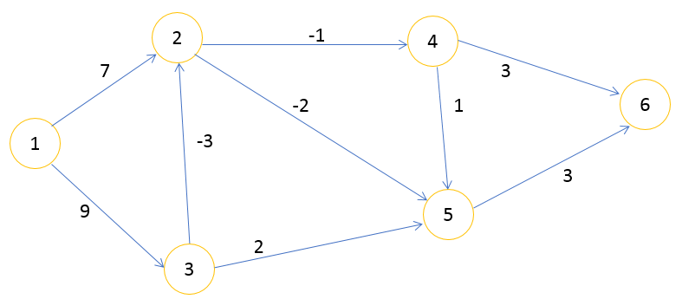

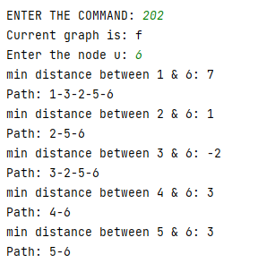

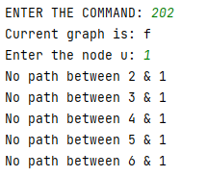

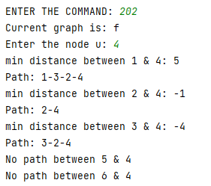

**Граф с положительными ребрами**



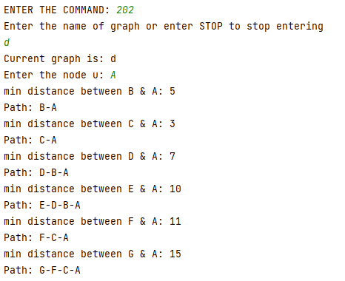

10. Веса IV с





Файл *main.py*

elif command == "FLOYD" or command == "203":  
 if cur_graph is None:  
 cur_graph = get_graph_by_name(None)  
 if cur_graph is not None:  
 print(f"Current graph is: {chosen_graph}")  
 print(f"Enter the node u: ", end="")  
 u = input()  
 print(f"Enter the node v1: ", end="")  
 v1 = input()  
 print(f"Enter the node v2: ", end="")  
 v2 = input()  
 if u not in cur_graph.nodes_list or v1 not in cur_graph.nodes_list or v2 not in cur_graph.nodes_list:  
 print("ERROR No such node")  
 else:  
 A, pr, cycle = tasks.floyd(cur_graph)  
 *# print(d, pr)* if cycle:  
 print('Negative-weight cycle found')  
 else:  
 if A[cur_graph.nodes_list.index(u)][cur_graph.nodes_list.index(v1)] != tasks.INF:  
 print(f"min distance between {u} & {v1}: {A[cur_graph.nodes_list.index(u)][cur_graph.nodes_list.index(v1)]}")  
 path = []  
 v = cur_graph.nodes_list.index(v1)  
 s = cur_graph.nodes_list.index(u)  
  
 while v != s:  
 *#print(v, pr[s][v])* path.append(cur_graph.nodes_list[v])  
 v = pr[s][v]  
 print(f"Path: {u}-{'-'.join(path[::-1])}")  
 else:  
 print(f"No path between {u} & {v1}")  
  
 if A[cur_graph.nodes_list.index(u)][cur_graph.nodes_list.index(v2)] != tasks.INF:  
 print(f"min distance between {u} & {v2}: {A[cur_graph.nodes_list.index(u)][cur_graph.nodes_list.index(v2)]}")  
 path = []  
 v = cur_graph.nodes_list.index(v2)  
 s = cur_graph.nodes_list.index(u)  
 while v != s:  
 *#print(v)* path.append(cur_graph.nodes_list[v])  
 v = pr[s][v]  
 print(f"Path: {u}-{'-'.join(path[::-1])}")  
 else:  
 print(f"No path between {u} & {v2}")

Файл *tasks.py*

def create_matrix_adj(gr):  
 n = len(gr.adj_list)  
 A = [[INF if i != j else 0 for i in range(n)] for j in range (n)]  
 for x in gr.adj_list:  
 a = gr.nodes_list.index(x)  
 for v in gr.adj_list[x]:  
 b = gr.nodes_list.index(v[0])  
 cost = int(v[-1])  
 A[a][b] = cost  
 if gr.type == "!directed":  
 A[b][a] = cost  
 return A  
  
  
def create_matrix_pr(gr):  
 n = len(gr.adj_list)  
 pr = [[None for i in range(n)] for j in range(n)]  
 for x in gr.adj_list:  
 a = gr.nodes_list.index(x)  
 for v in gr.adj_list[x]:  
 b = gr.nodes_list.index(v[0])  
 pr[a][b] = a  
 if gr.type == "!directed":  
 pr[b][a] = b  
 return pr  
  
  
def print_matrix(A):  
 for x in A:  
 for y in x:  
 if y == INF:  
 print(f"{'INF': ^5}", end=" ")  
 else:  
 print(f"{'None' if y is None else y: ^5}", end=" ")  
 print()  
  
  
def floyd(graph):  
 gr = graph.copy()  
 n = len(gr.adj_list)  
 A = create_matrix_adj(gr)  
 cycle = False  
 pr = create_matrix_pr(gr)  
 for k in range(n):  
 for v in range(n):  
 for u in range(n):  
 if A[v][k] != INF and A[k][u] != INF and A[v][k] + A[k][u] < A[v][u]:  
 A[v][u] = A[v][k] + A[k][u]  
 pr[v][u] = pr[k][u]  
 *#print(pr[v][u], pr[v][k], pr[k][u])* if A[v][v] < 0:  
 cycle = True  
 *# print('Negative-weight cycle found')  
 # return  
 # print(k)  
 # print_matrix(A)  
 # print()  
 # print_matrix(pr)  
 # print()  
 #print_matrix(pr)* return A, pr, cycle

Примеры

**Граф с циклом отрицательного веса**

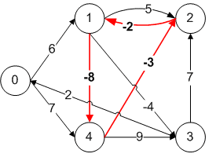

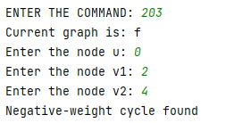

Уберем дугу (2, 1) – разорвем цикл

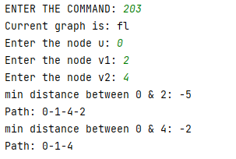

**Граф с положительными ребрами**



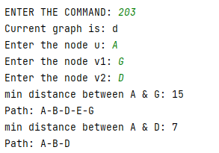

При добавлении изолированной вершины H

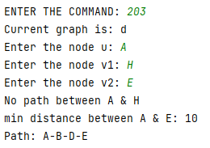

**Граф с отрицательными ребрами**



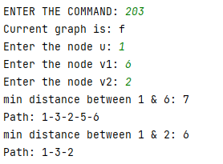

При добавлении изолированной вершины 7

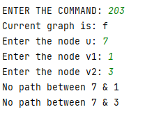

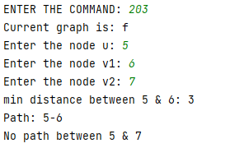

Потоки

11. Максимальный поток V



Файл *main.py*

Файл *tasks.py*

Примеры

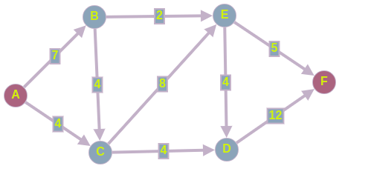

Творческая задача

Задание на визуализацию

